***Experiment-2***

***Aim:*** To execute the Linux general purpose commands and Linux file management commands.

**Theory:**

* **GENERAL PURPOSE COMMANDS**

**$cal :** It shows the calendar of the current month.

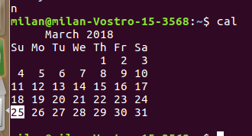

**$cal -y :** Displays the calendar of the entire current year.

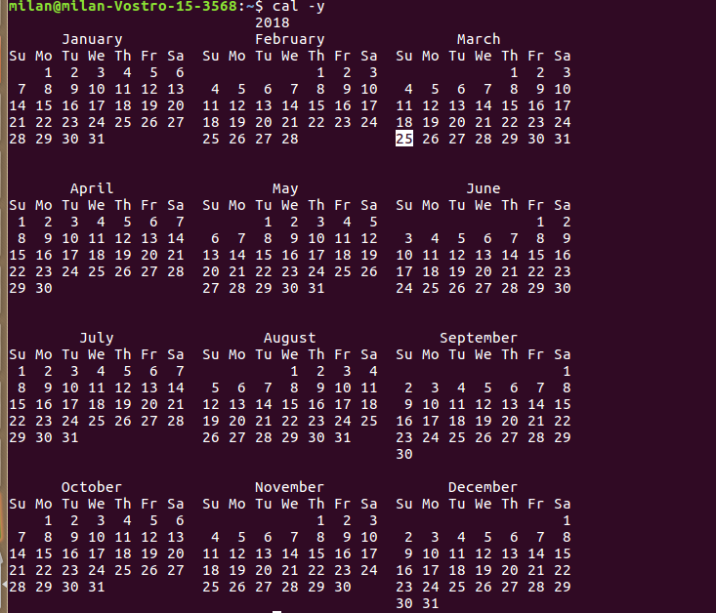

**$cal <month_number> <year> :** Displays the calendar of the specified moth of the specified year.

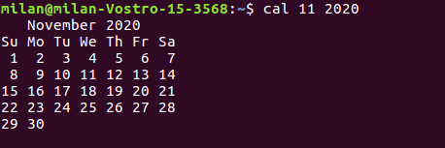

**$who :** Displays all the users of the current system.

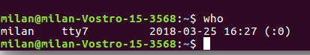

**$whoami :** Displays the user you are currently using.



**$echo :** Works like the print command. Eg: **$echo** “Hello” OR **$echo** Hello



**$date :** Displays the current date,month,day and the time.



**$time :** Displays the time statistics about the running of the command.

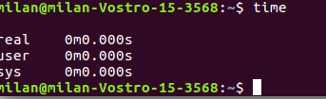

**$uname :** Displays the user name.



**$bc :** bc stands for Basic Calculator

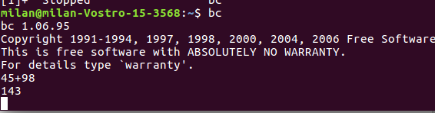

**$passwd :** Allows you to change the password of the current system.

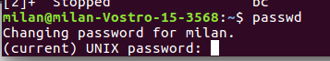

**File Management Commands**

**(FHS)File hierarchial System**

**$cp:** It is used to copy the contents of one file to another.

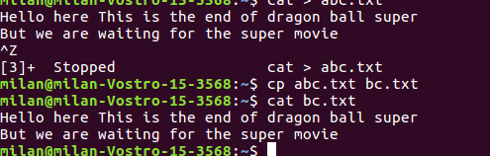

**$rm:** It is used to remove a specified file from the system

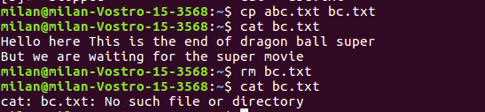

**$mv:** It is used to rename a file in the system.



**$mkdir:** This command creates a directory/folder in the current main directory.

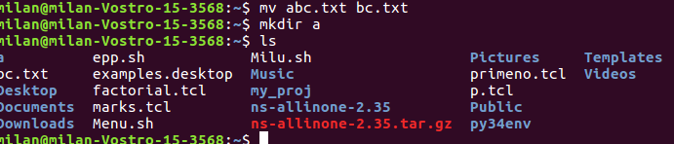

**$rmdir:** This command is used to remove a directory from the system. The only condition is that the directory to be deleted has to be empty.

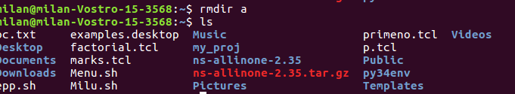

**$chmod:** This command is used to provide permissions to the specified file.

**$chmod <permission list> <filename>:** The permissions can be provided by specifying the permission list followed by the file name.

**$chmod <permission numbers> <file name>:** The permissions can be provided by specifying the permission numbers followed by the file name

**For Example:** If we wish to grant the following set of permissions:

1. The **u**ser can **r**ead,**w**rite and execute
2. The members of the **g**roup can **r**ead and e**x**ecute
3. **o**thers can only **r**ead, then

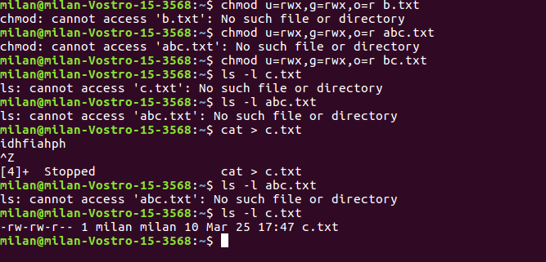

* **LINKING COMMANDS**

**$whatis <command name> :** Displays the description of the entered command.

**$whereis <command name> :** Displays the location/s of the entered command.

**$which <command name> :** Displays which of the locations of the entered command are being currently used.

**$users :** Displays the users on the current system.

**Changing permission commands**

**$ls -l :** Displays the contents and permissions of the current directory.

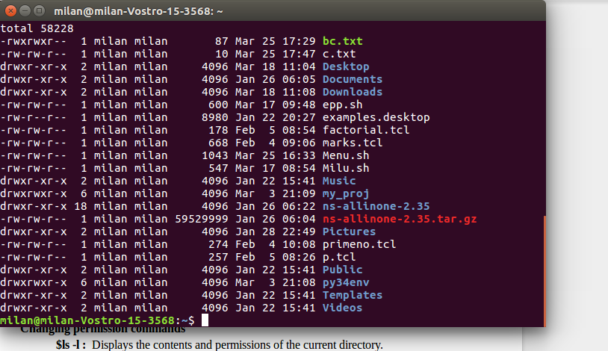

**$ls -l <file/directory name> :** Displays the contents and permissions of the specified directory or file.

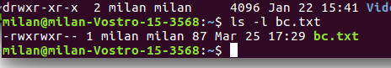

**$chmod <permission list> <file name> :** It is used to add or remove permission to owner or a group or others on the specified file. Permissions include read (r), write (w), execute (x).

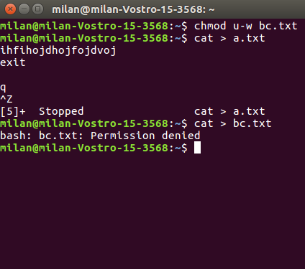

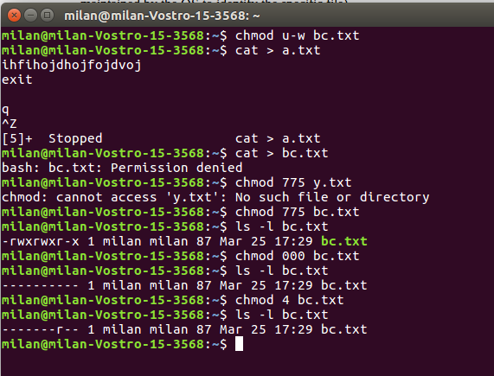

**$ln -s <original filename> <new filename> :** Creates a soft link between a.txt and b.txt

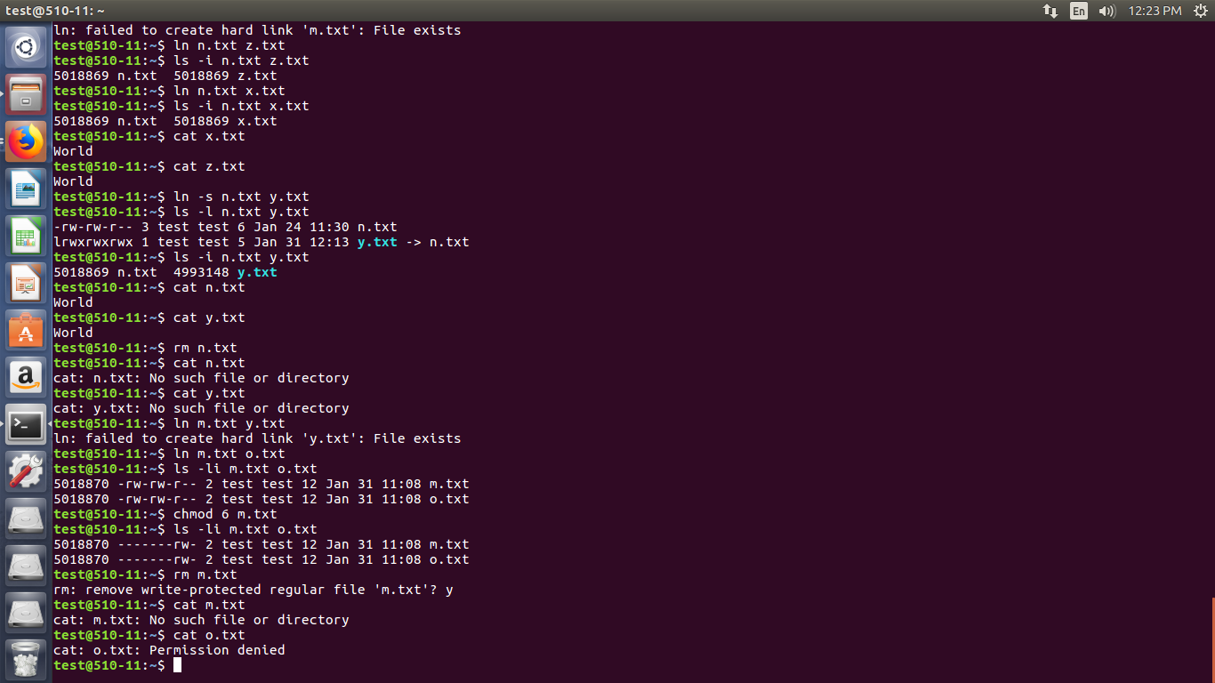

**$ls -i <filename> :** Displays the inode (i node is a unique number maintained by the OS to identify the specific file)

**$ls -li <filename> :** Displays the inode and the permissions given to the specified file.



**$ln <original filename> <new filename> :** Creates a hard link between the specified files.

Differences between softlink and hardlink:

In softlink the i-node of both the files is different and so are the permissions. Also if the parent/main file is deleted the linked file is also deleted.

In hardlink the i-node and permissions of both the files is the same. And even if the parent/main file is deleted the linked file remains the same.

**$ls -l > a.txt :** ‘>’ this is the output redirection operator

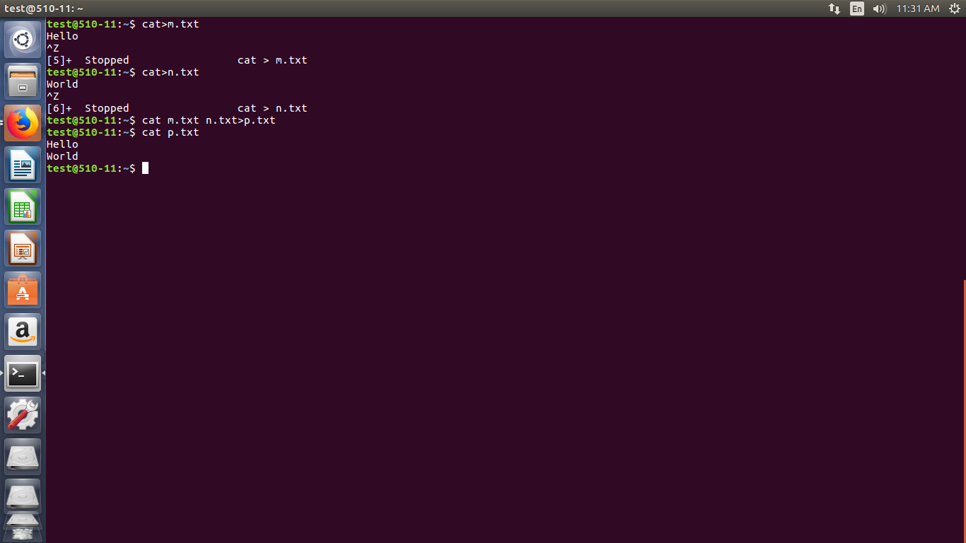

**Theory:**

**> and < :** Input output redirection transfer or redirects the default input/output stream to the given file. For example.

**$pipe :** $pipe is a form of redirection that is used to send the output of one program to another program for further processing. It is denoted by ‘**|**’

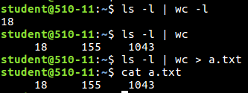

Conclusion:We have successfully execute the Linux general purpose commands and Linux file management commands.

-s